ML lec 01 - 기본적인 Machine Learning의 용어와 개념 설명

Machine Learning

· Limitations of explicit programming

- Spam filter : many rules

- Automatic driving : too many rules

· Machine learning : “ Field of study that gives computers the ability to learn

Without being explicitly programmed “ Arthur Samuel (1959)

Supervied / Unsupervised Learning

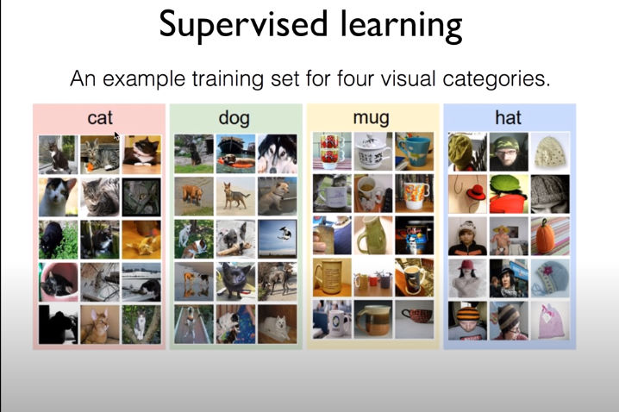

Ex) 이미지를 주면 cat 인지, dog 인지 분류해주는 것